**P5 – Illustrate the key computer system components and how they interact**

**Introduction**

In this assignment, I will illustrate how the CPU works and how it interacts.

**CPU**

CPU stands for central processing unit. This controls the main aspects of the computer. They are a number of unit that does specific jobs. An example of a CPU could be Intel, AMD and more. These names are given to identify different CPUs. They are the following: control unit, arithmetic logic unit, memory unit and input/output device. They have specific and important jobs for information to go around. As you can see the picture below, it shows how the CPU works within it.

[](http://www.google.co.uk/url?sa=i&rct=j&q=&esrc=s&source=images&cd=&cad=rja&uact=8&ved=0CAcQjRw&url=http://www.vg247.com/2014/01/06/mantle-update-for-battlefield-4-delayed-as-leaked-images-from-ces-show-45-advantage-over-directx/&ei=iD5SVL__CIHdav6mgOAD&psig=AFQjCNH-i4clEyFizUKvT1ZuScaKCJlliQ&ust=1414762468593374)[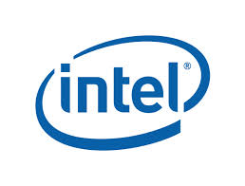](http://www.google.co.uk/url?sa=i&rct=j&q=&esrc=s&source=images&cd=&cad=rja&uact=8&ved=0CAcQjRw&url=http://www.aepona.com/careers/belfast/&ei=Mj5SVKilJMXmarLIgagE&bvm=bv.78597519,d.ZGU&psig=AFQjCNFPqMQUNCXv8kCM9-zGhR1z3uqGzQ&ust=1414762411961886)

**Von Neumann architecture**

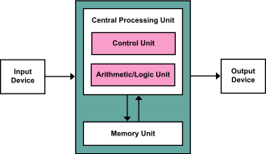Von Neumann architecture, also known as Von Neumann model, is based on how a computer is designed and how it works. Von Neumann was a person that first published how it worked. This included Arithmetic Logic Unit (ALU), Memory, Input/output and a Control Unit. Many computers that are designed today, these features are included within every system. As these features are included, there is a model that makes up this. This image, on the right, shows the Von Neumann model. As you can see, each feature has each different job to do.

**ALU, I/O, Memory, Control Unit.**

**Input** records all the information, codes it and sends it to the computer. It is processed and the **output** sends it to the direct person of whom it is aimed at. Within these processes, they are Control Unit, Arithmetic Logic Unit and Memory Unit. **Arithmetic Logic Unit** performs operations such as multiply, addition, subtraction and division. The **Control Unit** controls these operations. Control Unit sends signals to other units. This can be between the memory and the processor. As any **memory**, once it is been converted, it stores the converted information. They do not store memory like writing. It is a binary code. Some could be stored differently and separately. It can be stored in a Random Access Memory (RAM) or ROM (Read Only Memory).

**RAM** is known as random access memory is used to store data. This is inserted on the motherboard, which it is located there. When the computer is switched on, the files that are stored on the RAM automatically be operating as long as the computer is running. All the documents that you create is stored on the RAM.

**ROM** is known as read only memory. This is where data that is stored on this memory, but this cannot be changed. This is much different to RAM. ROM is where data is stored permanently on to this chip. As well as storing data, this gives out instructions.

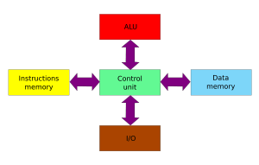**Harvard architecture**

Harvard architecture is all separated out. They have separate instructions for each of them. This architecture contains instruction memory, control unit, data memory, I/O and ALU. They are not all connected together. As shown on the diagram (right), it demonstrates the model of the Harvard architecture. It has separate units for each of them. I/O stands for input and output. This is different to the Von Neumann architecture, because Von Neumann share the same bus, whereas Harvard uses different buses.

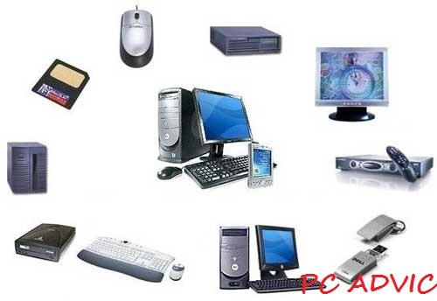**Peripherals**

Peripherals are devices that are attached to the computer, which is not controlled by the processor of the computer. This can be physical items that are attached to the computer. Any of these items that are attached, it can make it easier for the user to use. For example, having a mouse makes it easier for the user by controlling the curser easier and moving it around. An example of input devices are camera, scanner, and mouse. An example of output devices are monitor, printer. For example, a keyboard is attached to the computer for it to work. It is attached to it, not built into it. Referring to the picture, it shows many examples that is controlled by the processor.

**Bus**

A bus, in computing terms, is referred to a set of wires that connect any independent components of the system, so they can pass signals between the two of them. There is not only one of bus, as you can see below; they are many of them. Each of the bus have different jobs and I am going to be explaining what each of them are going to be doing.

**Data Bus**

Data bus is designed to control the data. They are wires that make up these buses and these wires are the width of the bus. Data bus consists of 32 wires and these wires can be connected with two or more components within the computer. These wires are used to send information between the two. In this case, this bus will send data. Referring to the image below, data bus can send information between each of the components. For example, Input/output can transfer data between the two with memory using data bus. If I were to send data to another computer, within this system, data bus can send it from I/O to memory.

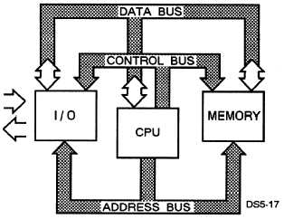

**Address Bus**

Address bus is similar to ‘data’ bus, but does the total opposite. This bus delivers the destination that the user requires. This means, if I were to send an email to my teacher, it would travel from I/O to its destination. This has 32 wires, same as data bus. The picture above shows how the address bus works. It gets the picture, email or whatever it needs to send to another person and it locates it by the IP address and sends it. It is simple the way it works.

**Control Bus**

Control bus, consisting of eight wires, that sends signals between the components that it is connected with. All of these buses work together. The address bus carries on information on, and the data bus carries on the actual data and the control bus carries command from the CPU, and the information that is received, it is send to the other buses for the specific data to be send to the target.

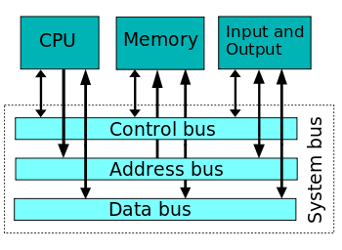**System Bus**

System bus is a single bus that connects all the buses, which are named above, are all-together. This seems unnecessary, but it is used to reduce cost. The picture shows how a system bus is. All these arrows are buses that communicate with the components within the computer.

**Clock**

In computing, clock is the speed of it. Speed of the computer no matter, which computer you use. This is measured by the ticks per second. They are different processors and the speed is among it. For example, if you want to choose between Intel i3 and Intel i5. Intel i5 processes information much faster. Clock speed is important for any computer. If the computer is slow, there is no point of it. Clock speed is measured by MegaHurtz (MHz). 1 MHz represents 1 million cycles per second, and I GHz is represented as one thousand million per second.

[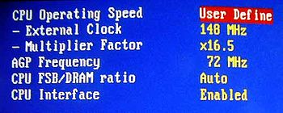](http://en.wikipedia.org/wiki/File:Overclock.jpg)**Overclocking**

Overclocking, technically, is forcing a specific component of the computer to work faster if necessary. This can be changed by changing the operating voltage. The picture shows how it works. If you want to change it, you can, but it has to be specific and very careful to do. This is only done on rare occasions.

**Registers**

Registers are hold information and data together. The registers are part of the processor, not got to do with the memory, or other storage devices. They are different types of registers within it, and they all have a different job. They could be instruction, address, and storage registers. They all do as the ‘title’ suggests e.g. storage – this would store the data. They is an accumulator that collects all the results together. General-purpose register have several functions for the process e.g. arithmetic operations –when the conversions happens for it. As I have said before, each register is different. Special purpose register controls the various aspects of the function. This could include:

* I/O peripheral
* Stack limit
* Processor status

**Single Core**

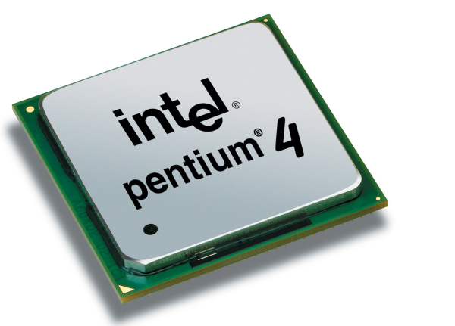A single core is performs one task each time. The disadvantage is that it will take time and if the user is impatient, it will crash. Obviously, each of the Intel processors named, they have different speed and cores. They have an electrical path that allows communicate between other components. ”. The processor holds instructions which is given to the programmers. An example of a single core is Intel i3.

**Multiple Core**

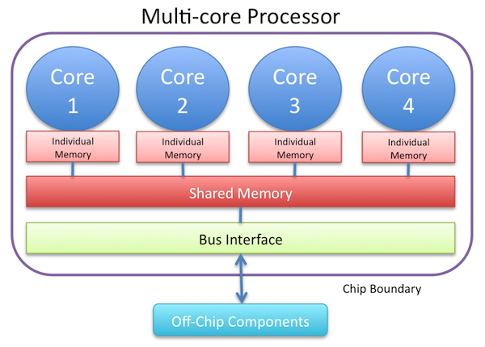A multiple core is a single component that has different cores within it. The advantage of having these ‘cores’ is that multiple instructions can be run at the same time. As a single core, one instruction has to be set and complete for the other one to be done, but for multiple core, it works all-together. The picture below shows how multiple core works. An example of a multiple core could be Intel i5 and Intel i7.

**Reference**

* <http://en.wikipedia.org/wiki/Von_Neumann_architecture>
* <http://en.wikipedia.org/wiki/Harvard_architecture>
* <http://en.wikipedia.org/wiki/Harvard_architecture#mediaviewer/File:Harvard_architecture.svg>
* AQA AS Computing by Nelson Thornes pg. 146 to 153.
* <http://it.wikipedia.org/wiki/Single_core>
* <http://en.wikipedia.org/wiki/Multi-core_processor>
* <http://en.wikipedia.org/wiki/Overclocking>